Author: Matthew Eagleman
Date Created: 1/12/2026
Project Artifacts
Add A* pathfinding to project (Connor)
Description:
Find an A* pathfinding package that we can import into our project, and set it up.
Notes:
- Look for specifically unity 2d
- You can make a new branch to test out different algorithms

Create UML diagram for the file architecture (Alex Lee, Conner, Anyone else who wants to)
Description:
Create a uml diagram showing a broad overview of all the different files and mechanisms and how they’ll interact with each other.
Notes:
- This doesn’t have to get incredibly specific, we’ll go into more detail for specific areas as the project goes along.
- It’ll be best if 2 or 3 people take this on
- It might be a little confusing because some of the files are already named, we will use some of them, and scrap others.
- We will have a meeting for this later this week.

Add player movement (Trevor, and owen)
Description:
Make the player move.
Notes:
- The inputs will be the arrow keys.
- We will use the new input system
- There is already a “movement.cs” file attached to the player, you can just use that file and delete the old code.
- Make a new branch until it is working properly
- The 1-5 design docs have a link to an overview of unity’s input system.

Create kitchen assets
Description:
Create art for the game. Here’s what we know we need so far:
- Fridge
  - Fridge decorations (pictures, magnets, etc.)
- Table
- Chair for table. We will flip it to create 2
- Center island
  - Sink
- Counter
  - Oven/Stove
- Upper cabinets
  - Microwave
- Potted plant
- Knife set
- Fruit basket
- Candles
- Knife
- Cutting board
Notes:
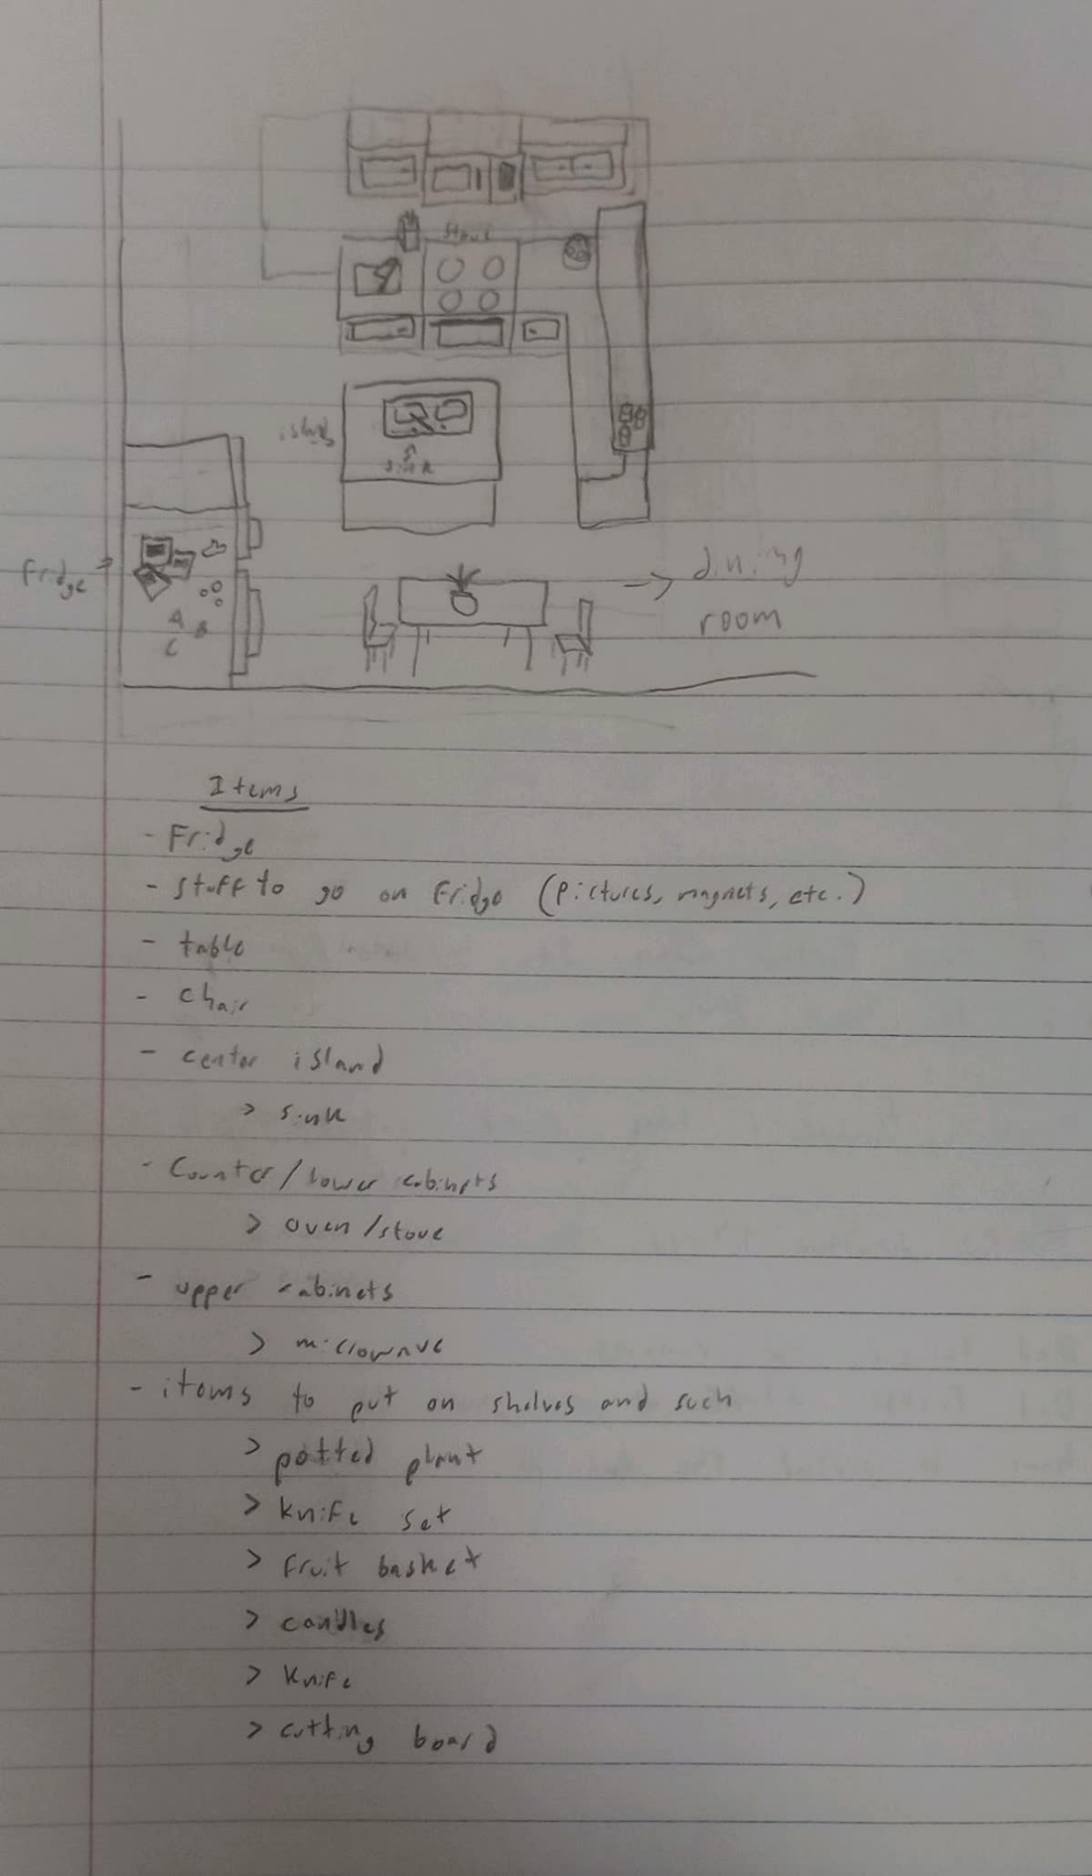
- The player character is 4’ 6’’
- An 8px by 8px square is 1’6’’ by 1’6’’
- Look at the art i’ve already made for the basement/michaels room for reference on the art style

Create art guides
Description:
Create a guide in this format for different rooms of the house. Rooms we still need are:
- Attic (Alex Lee)
- Upstairs bathroom
- Parents closet (Connor)
  - Bedroom, Bathroom, and Closet
- Upstairs hallway
- Parents bedroom (Connor)
  - Bedroom, Bathroom, and Closet
- Parents bathroom (Connor)
  - Bedroom, Bathroom, and Closet
- Gus’s room (Sam)
- Gus’s closet (Sam)
- Mid level bathroom (Trevor)
- Living room (Trevor)
- Office
- Dining room
- Mid level Hallway
- Boiler room (Alex Lee)
- Pool/Bar area
- Garage (Alex Lee)
- Front Yard
- Backyard
- Treehouse
Notes:
- Use the same format as the kitchen

Future artifacts
- Create Gameobjects for assets
- Decorate rooms

